Shahbaj Singh
Milestone One: 3D Scene Proposal

The selected 2D scene is a side-scrolling 2D platform game environment (see Figure 1 below). The scene depicts a simple game level featuring geometric shapes rendered with color gradients against a gray background, characteristic of early-stage game development environments. The scene contains a ground plane, a character or object represented by a triangle, a platform ledge, and directional lighting cues visible through the gradient shading on the shapes. This type of scene provides an excellent foundation for replication in 3D because it involves clearly defined geometric primitives, flat surfaces, and recognizable spatial relationships between objects.
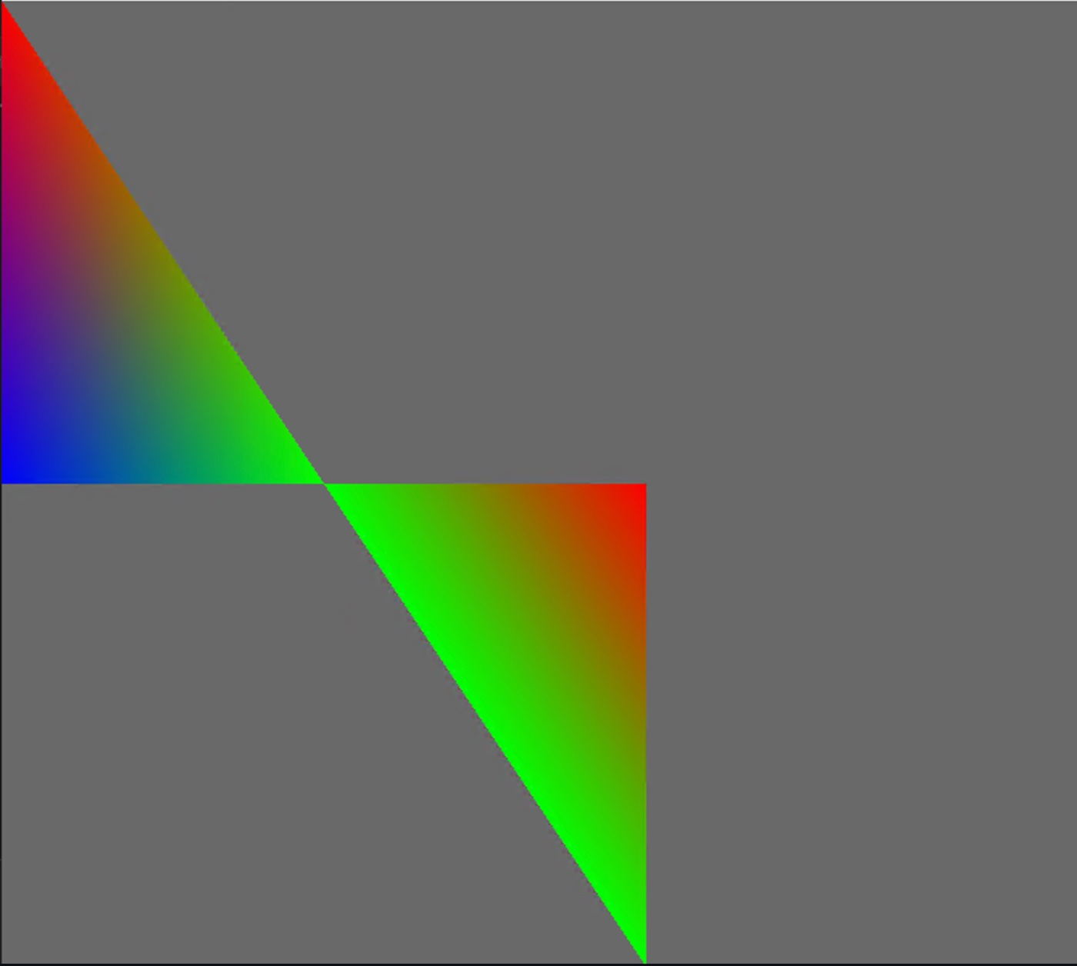

The following four objects from the scene have been selected for 3D replication:
- Ground Plane – The flat horizontal surface that extends across the bottom of the scene. This is an ideal choice because every 3D scene requires a grounding surface, and the large, flat area makes it straightforward to replicate.
- Player Character / Triangular Object – The colored triangular shape in the upper-left of the scene, rendered with a red-to-blue gradient. This object is a good choice because it can be constructed from multiple basic 3D primitives to form a more complex figure.
- Platform Ledge – The elevated horizontal platform visible in the lower-center of the scene. Platforms are core elements in side-scrollers and offer an opportunity to work with box and plane shapes stacked together.
- Background Wall / Backdrop – The large gray rectangular area that fills the scene background. Replicating this as a vertical plane provides depth to the 3D environment and simulates the feel of an enclosed game level.
These objects collectively represent a realistic yet achievable scope of work. Each object maps naturally to fundamental 3D shapes and together they create a complete, visually interesting scene. The combination of flat planes, a complex character object, and elevated geometry ensures a variety of shapes are exercised throughout the project.

Each of the four selected objects will be broken down into the following basic 3D shapes:
- Ground Plane – A single Plane shape. This is the most appropriate primitive for a flat, infinite-feeling ground surface. It will anchor all other objects in the scene and provide a surface for shadows and reflections.
- Player Character – A Pyramid for the body (replicating the triangular silhouette visible in the 2D image) combined with a Sphere for the head. This combination of two shapes satisfies the requirement that at least one object be composed of two or more basic 3D shapes. The pyramid captures the pointed, angular quality of the 2D triangle, while the sphere adds a rounded humanoid head element.
- Platform Ledge – A Box shape. The rectangular, flat nature of the platform maps perfectly to a box primitive. Its dimensions can be scaled to be wide and thin, precisely matching the ledge visible in the 2D scene.
- Background Wall – A Plane oriented vertically. Using a plane for the back wall is consistent with how game engines handle backdrop geometry and keeps the scene performant while providing realistic depth.
In summary, the scene will use five distinct basic 3D shapes: Plane (x2), Pyramid, Sphere, and Box. This meets the requirement of at least four different basic 3D shapes and ensures the scene is varied, interesting, and technically achievable within the scope of the course project. The chosen objects are exciting enough to produce a visually meaningful scene while remaining straightforward to model, texture, and illuminate in OpenGL.

